Company Overview
SIC Insurance Company Limited is one of the oldest non-life (general business) insurance companies in Ghana. State Insurance Corporation was incorporated in February 1962 by Executive Instrument (E.I) No.17, which was passed under the Statutory Corporation Act, 1962 (Act 232). It was established as a corporate body by L.I. 424 of 1964 with an initial paid-up capital of ₤1 million. On August 28, 1995, the Corporation was converted into a Public Limited Liability Company and renamed State Insurance Company of Ghana Limited. It was re-registered under the Companies’ Code, 1963 (Act 179) and currently has a paid up capital of ¢25 billion.
The company went public in 2007, when the Government of Ghana offered 60% of its shares, its IPO was oversubscribed by 97% .The government of Ghana retained a 40% equity after it listed on the Ghana Stock Exchange. As at September 2009, the company’s assets totaled GHc185.374 with a gross premium of GHC 56.877m. . Recently, the company’s management is on the project to expand its operations across the West African sub – region targeting Sierra Leone and Liberia as the most viable opportunities.
Products
Its business operations cover fire, motor, marine, aviation, general accident and policies for the hospitality Industry.
Oil & Gas
In the light of the Oil find along the western coast of Ghana, the company has positioned itself to underwrite Oil and Gas and other ancillary business in the country. Further to this, GHANA INSURERS ASSOCIATION (GIA) as a way of building capacity and positioning itself to adequately handle all related insurances on Oil and Energy Risks, formed a consortium. All insurances relating to exploration, drilling through to production of oil and gas are placed in the consortium and a Manager is appointed, with the core responsibility of managing the entire portfolio.SIC Insurance Company was appointed as the Consortium Manager, based on our Capital Base, Human Resource Capacity, Track record among other things. This responsibility involves dealing with all the local insurance companies participating in the consortium, the clients and other stakeholders as well as the overseas reinsurers.
Market Share
SIC is a leading provider of general or non-life insurance products in Ghana with an estimated Market share of 26%.
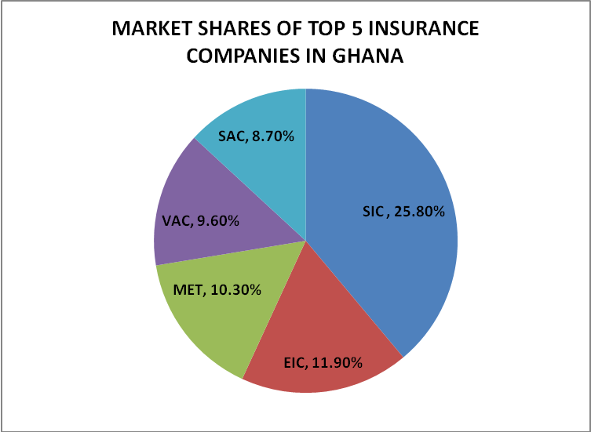

CORPORATE DIRECTION

Corporate Vision
- We will maintain our dominance in the Insurance industry

Corporate Mission
- To provide innovative and competitive insurance and allied financial services to our clients through a highly skilled and motivated workforce with a commitment to deliver value to all stakeholders.
- CORPORATE VALUES (OUR PEOPLE PROMISE)

At SIC, we customize the insurance products for every client - the right product for the right person at the right time!
Achievements / Awards
- SIC Insurance Company is a member of the Ghana Club 100
- Four years running Insurance Company for the year adjudged by the CIMG
(Chartered Institute of Marketing, Ghana) (2003 – 2007).
- The First Insurance Company in Ghana to be ushered into the
CIMG Hall of Fame category, Insurance category two years running (2008&2009).
- Internationally AA rated by Global Credit Rating, South Africa.
The Global Credit Rating Company (GCR) of South Africa in December, 2009 rated SIC Insurance Company Ltd “AA” in claims paying ability. The rating by GCR reflects an evaluation of an Insurer’s current financial position as well as how its financial position may change in the future. This means that SIC has a very high claims paying ability, the highest independently rated Insurance Company in Ghana, its protection factors are strong and risk exposure is modest.

Reinsurers
In order to get maximum protection for the Insurances underwritten, SIC Insurance Co. Ltd has very reputable Reinsurers and Reinsurance Brokers.
The purpose is to enhance its capacity and financial security to underwrite any risk.
The Reinsurers/Reinsurance Brokers include the following:
AON Group Ltd. - U.K.
Afro-Asian Insurance Services - UK
African Reinsurance Corp. - Nigeria
Assicurazioni Generali Trieste - U.K.
BEST Reinsurance – Tunis - Tunisia
Hannover Reinsurance Co. - South Africa
Marsh Ltd. - U.K
Munich Reinsurance Co. - South Africa
Financial Performance

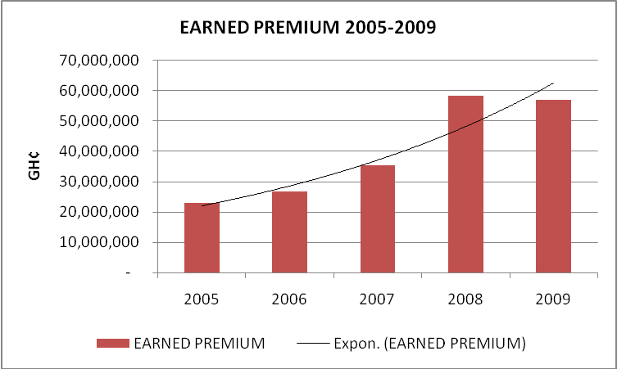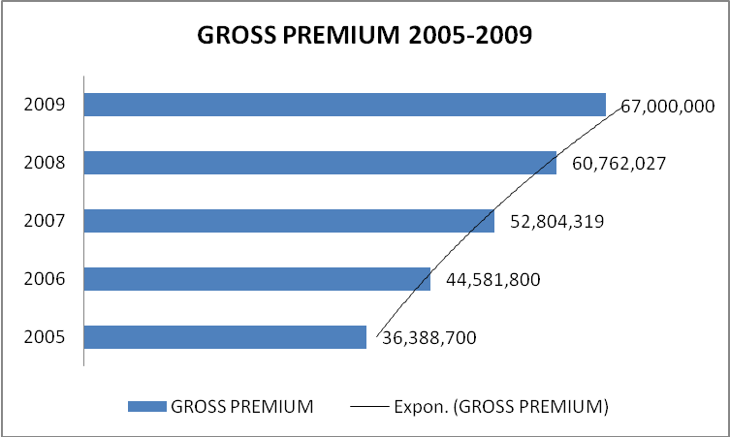

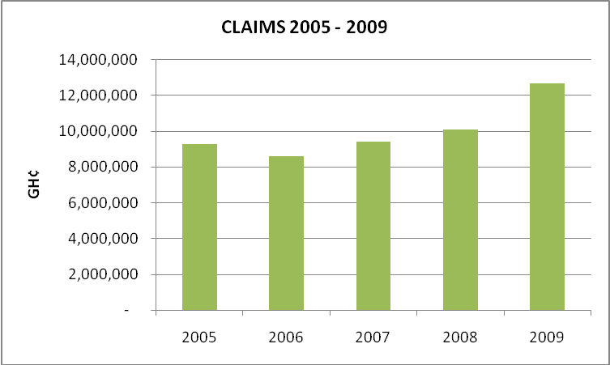

Head Office
No. 28/29 Ring Road East
Nyemitei House
Adjacent UNDP Office
P.O. Box 2363, Accra
Tel. 233-21 780600-9
Fax: 233-21-780615
E-Mail: sicinfo@sic-gh.com
Website: ww.sic-gh.com
Facebook: SIC INSURANCE

